Using GitHub Desktop
for updating the
Ethos screenshots

Table of Contents
Overview 4
Preparation 4
Localizing the forge 8
Localizing the screenshot macros 9
Updating Ethos screenshots 9
Background 13

Overview
This document describes how to use Github Desktop to update the ethos-manual screenshots on GitHub.

There is a difference in philosophy between the way we use GitHub when doing the manuals and now when updating the screenshots.

When working on the manual we do not work in the local GitHub repository, instead we copy our screenshots from ethos-manual\<language>\assets to our local assets folder below the manual. This process is described in my “[EN] Github_how_to_rev5.pdf” document found in ethos-manual\english\docs.

To update the screenshots we have to work inside the local GitHub repository. Once updated, we revert to working on the manual outside the local repository as before.

Preparation
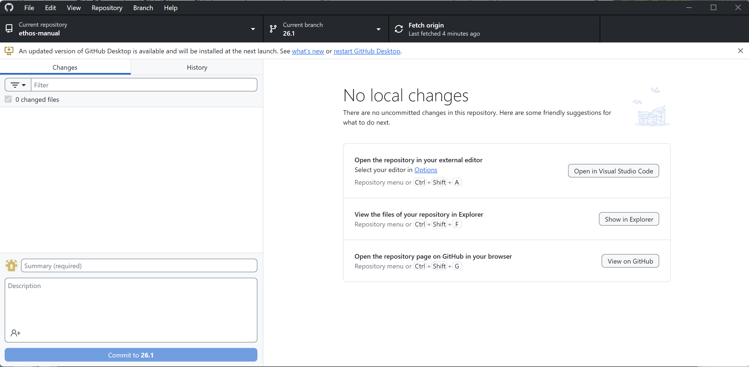

1. Do a Repository / Pull in GitHub Desktop as usual.

2. Click on ‘Show in Explorer’.

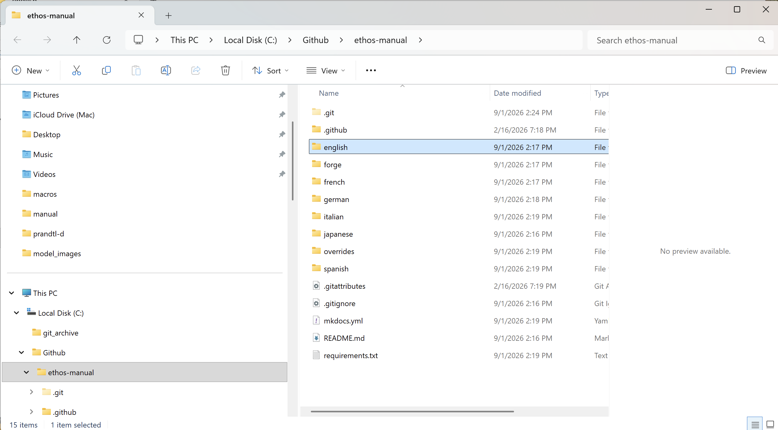

3. A Windows Explorer window will open in your local GitHub repository.

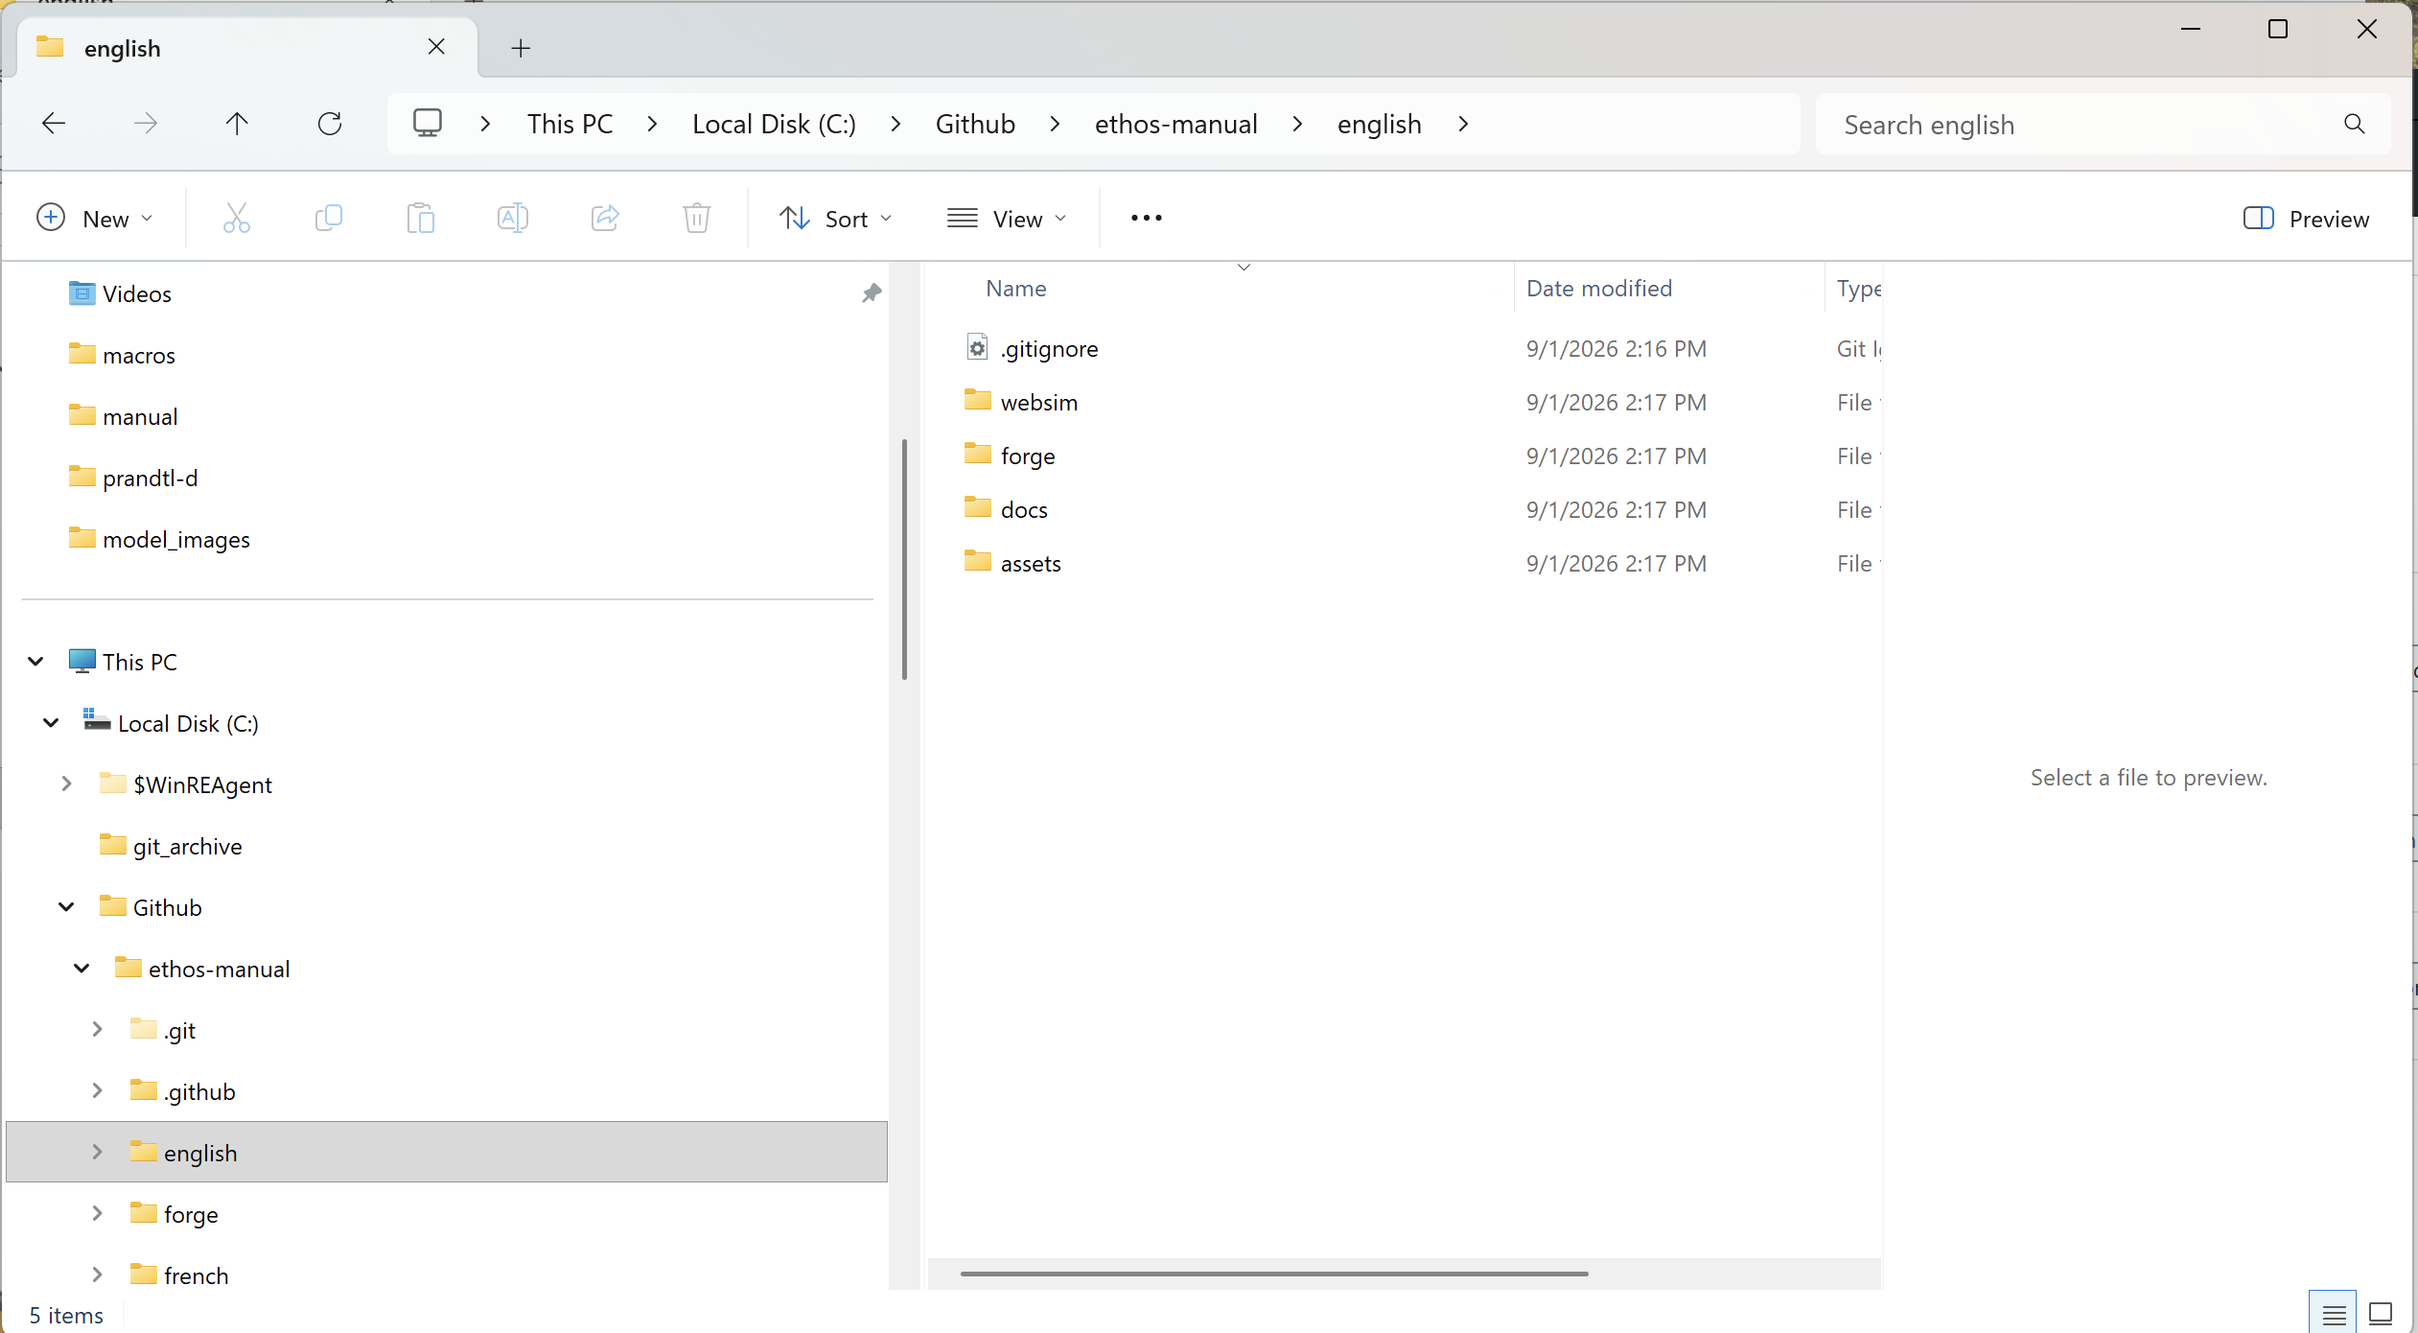

4. Open the folder for your langauge.

5. You will need to install some additional software for running the Python scripts and generating the images.

6. Right-click on an empty space in any folder and select "Open in Terminal."

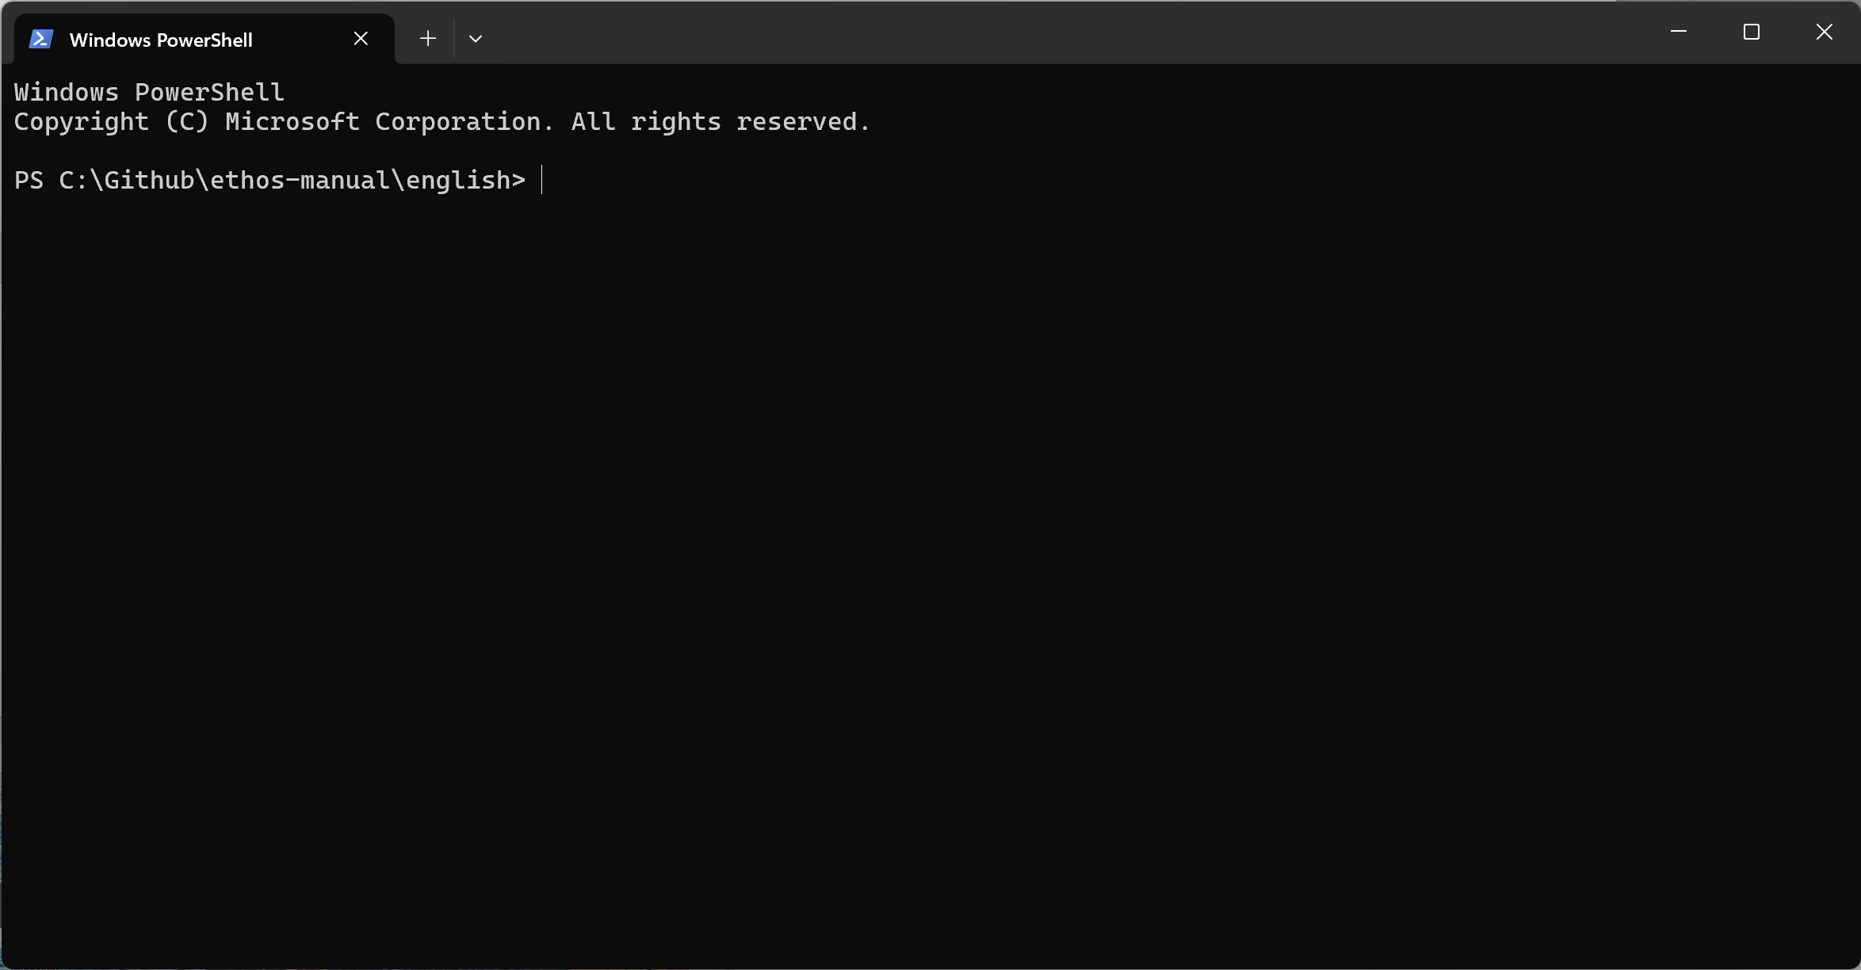

7. A Terminal window will open.

8. Type the command “Python” and Enter.

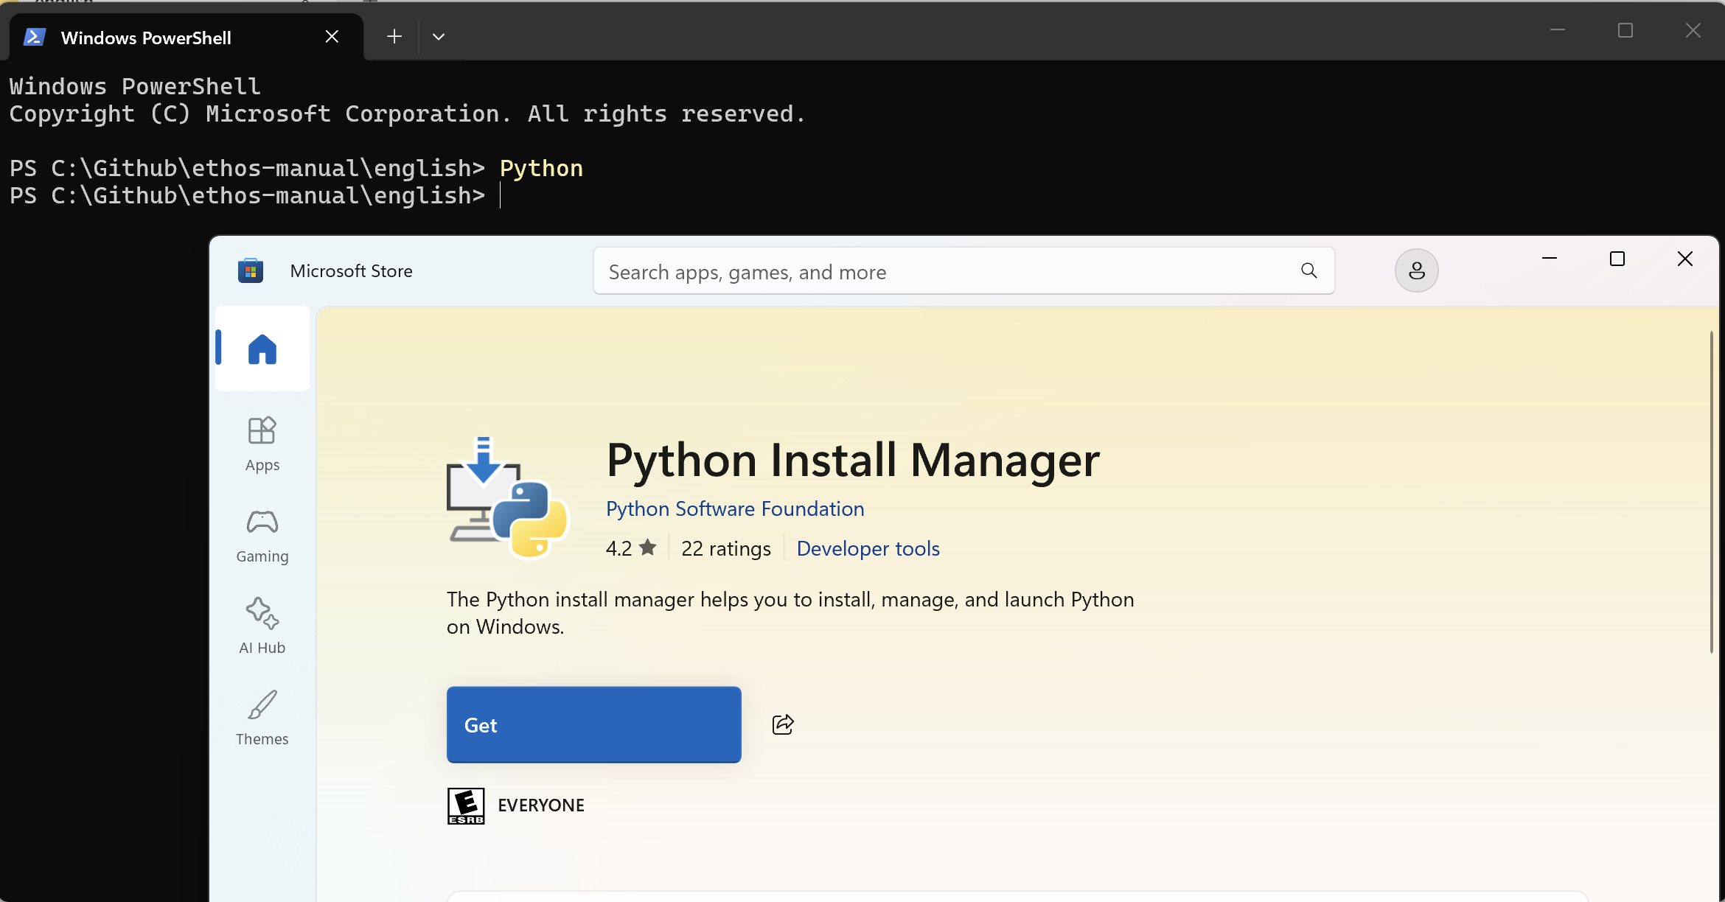

9. If Python is not installed, the MS store Python page will open so you can install it.

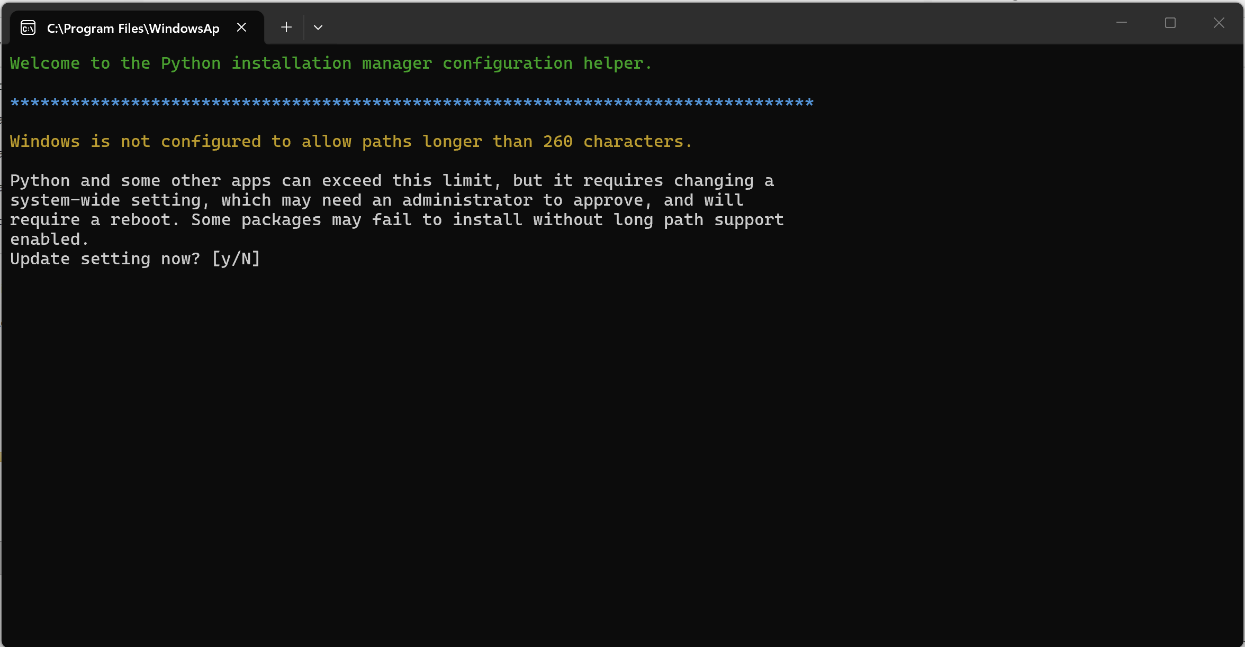

10. You may need to allow the increase of path length, configure the global shortcuts directory and download the latest Python runtime.

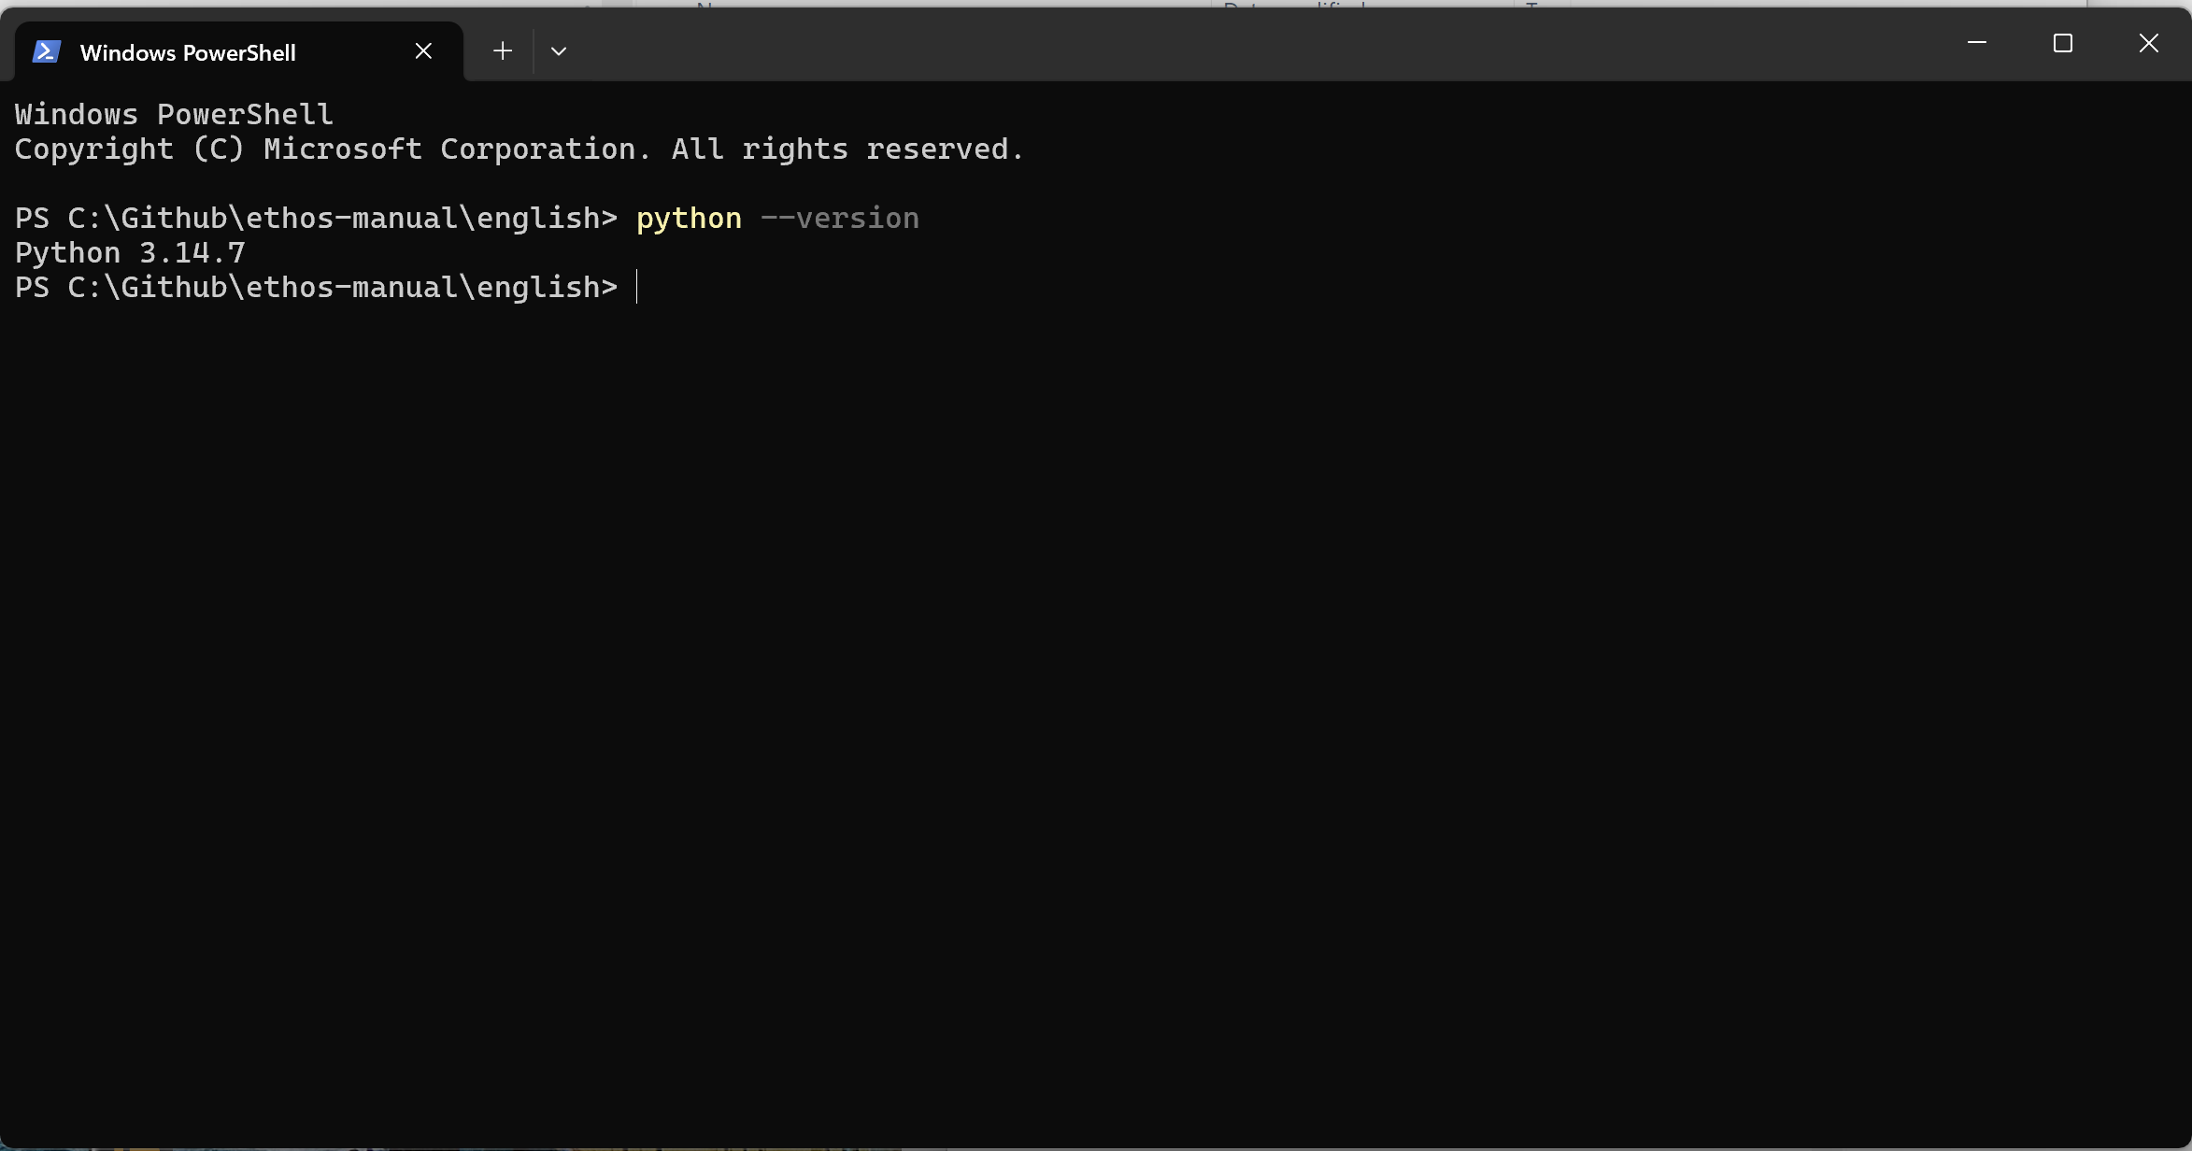

11. Finally run the command ‘python –version’ to confirm the installation.

12. Now download Node.js by going to https://nodejs.org/en/download

13. Install the downloaded Node installer. (Note I did not install the optional additional tools which take up 6Gb.)

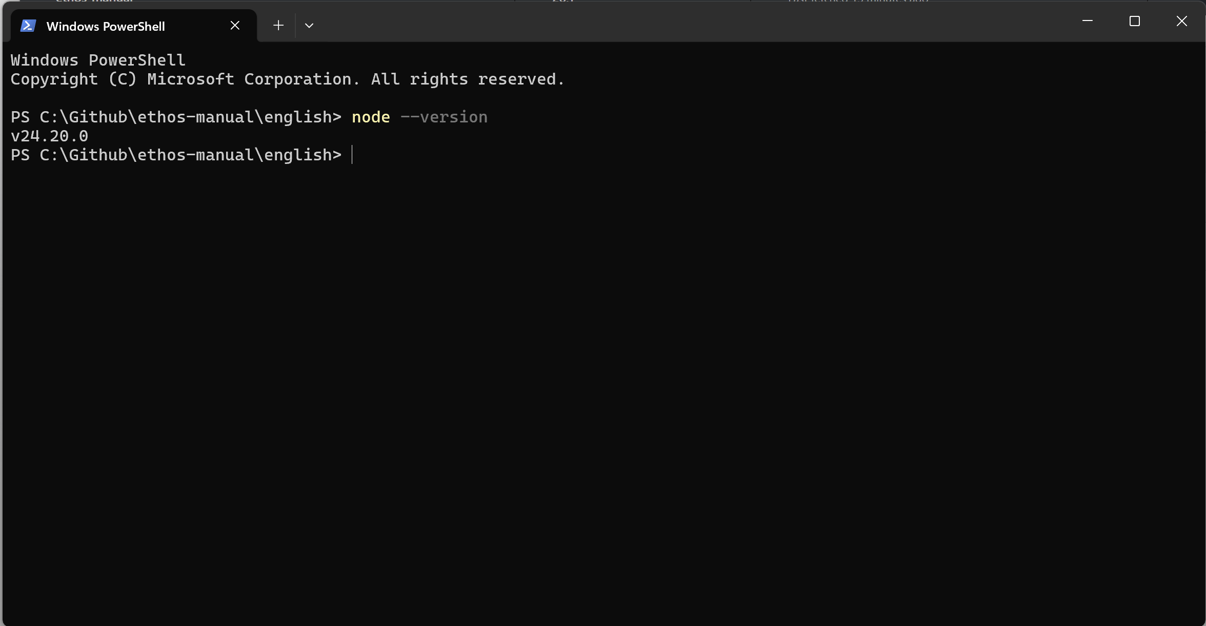

14. Repeat with the command “node –version”.

15. Now you can use python to install Pillow for Python (this is used for images generation). In the Terminal enter
`python -m pip install pillow`

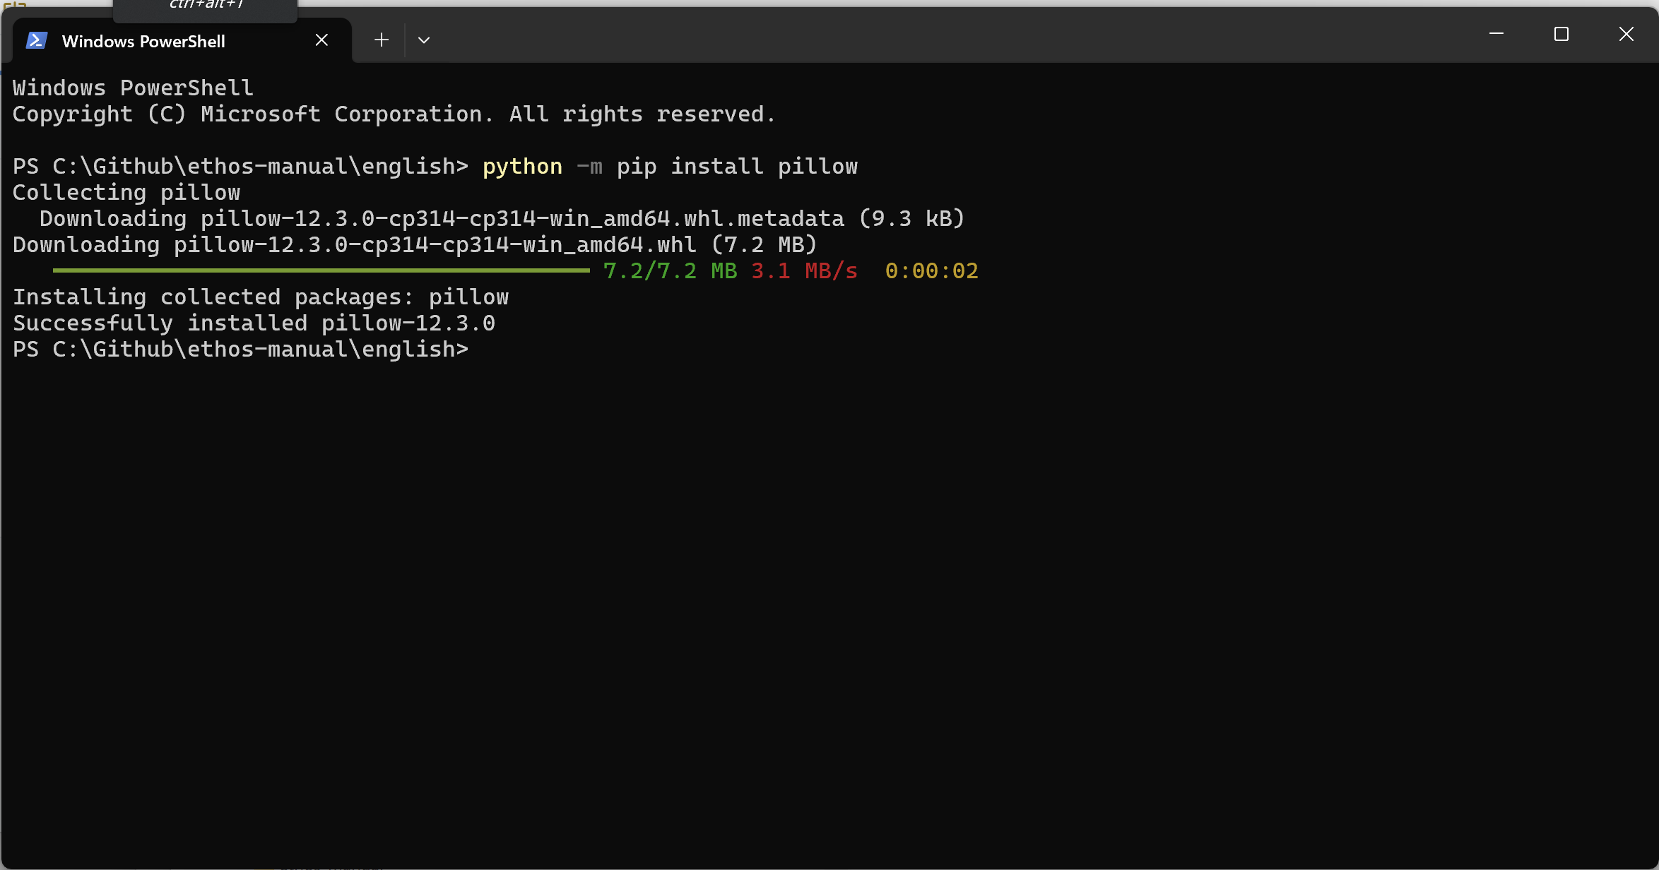

16. Pillow has been installed successfully.

17. You are now ready to update screenshots.

Localizing the forge
To run the ‘WASM’ simulator in your language you need to copy localized radio.bin files into your local ‘forge’ folder.

1. Copy ethos-manual/forge/X20S_FCC.bin to radio.bin
2. Zip this radio.bin into a radio.zip
3. Open the online web simulator with X20S and 1.6.6
4. Upload a backup in the online simulator, with just this radio.zip
5. The radio starts, skip the wizard
6. Change the System/General settings for display to your <language>, select your keyboard if required, choose the Audio language and 2 voices
7. Create a backup from the simulator
8. From this backup extract the radio.bin and write it in <language>/forge/X20S_FCC.bin. Take care! Do not copy it into ethos-manual/forge, only into your <language>/forge!
9. Now you are ready to launch the screenshots.py commands described below.

Repeat the above steps for X18S_FCC, X20PRO_FCC, X20PROAW_FCC, XERS_FCC.

Localizing the screenshot macros
Before updating your screenshots, you should check that the ‘translations.lua’ file in your
C:\Github\ethos-manual\<language>\forge\macros folder is up to date.

Normally you can ignore lines that specify a position, but these lines below select the position of audio files in the drop-down list. If the sound file positions between langauges are not fully synchronised, you may need to adjust the position to select the correct audio file:

Timer1FilePosition = 228, -- position of "timer-1-elapsed" wav file
Timer2FilePosition = 231, -- position of "timer-2-elapsed" wav file
VFRlowFilePosition = 250, -- position of "vfr-low"

Updating Ethos screenshots

1. Do a Repository / Pull in GitHub Desktop as usual.

2. Click on ‘Show in Explorer’.

3. A Windows Explorer window will open in your local GitHub repository.

4. Open the folder for your langauge.

5. Right-click on an empty space in any folder and select "Open in Terminal."

6. A Terminal window will open.

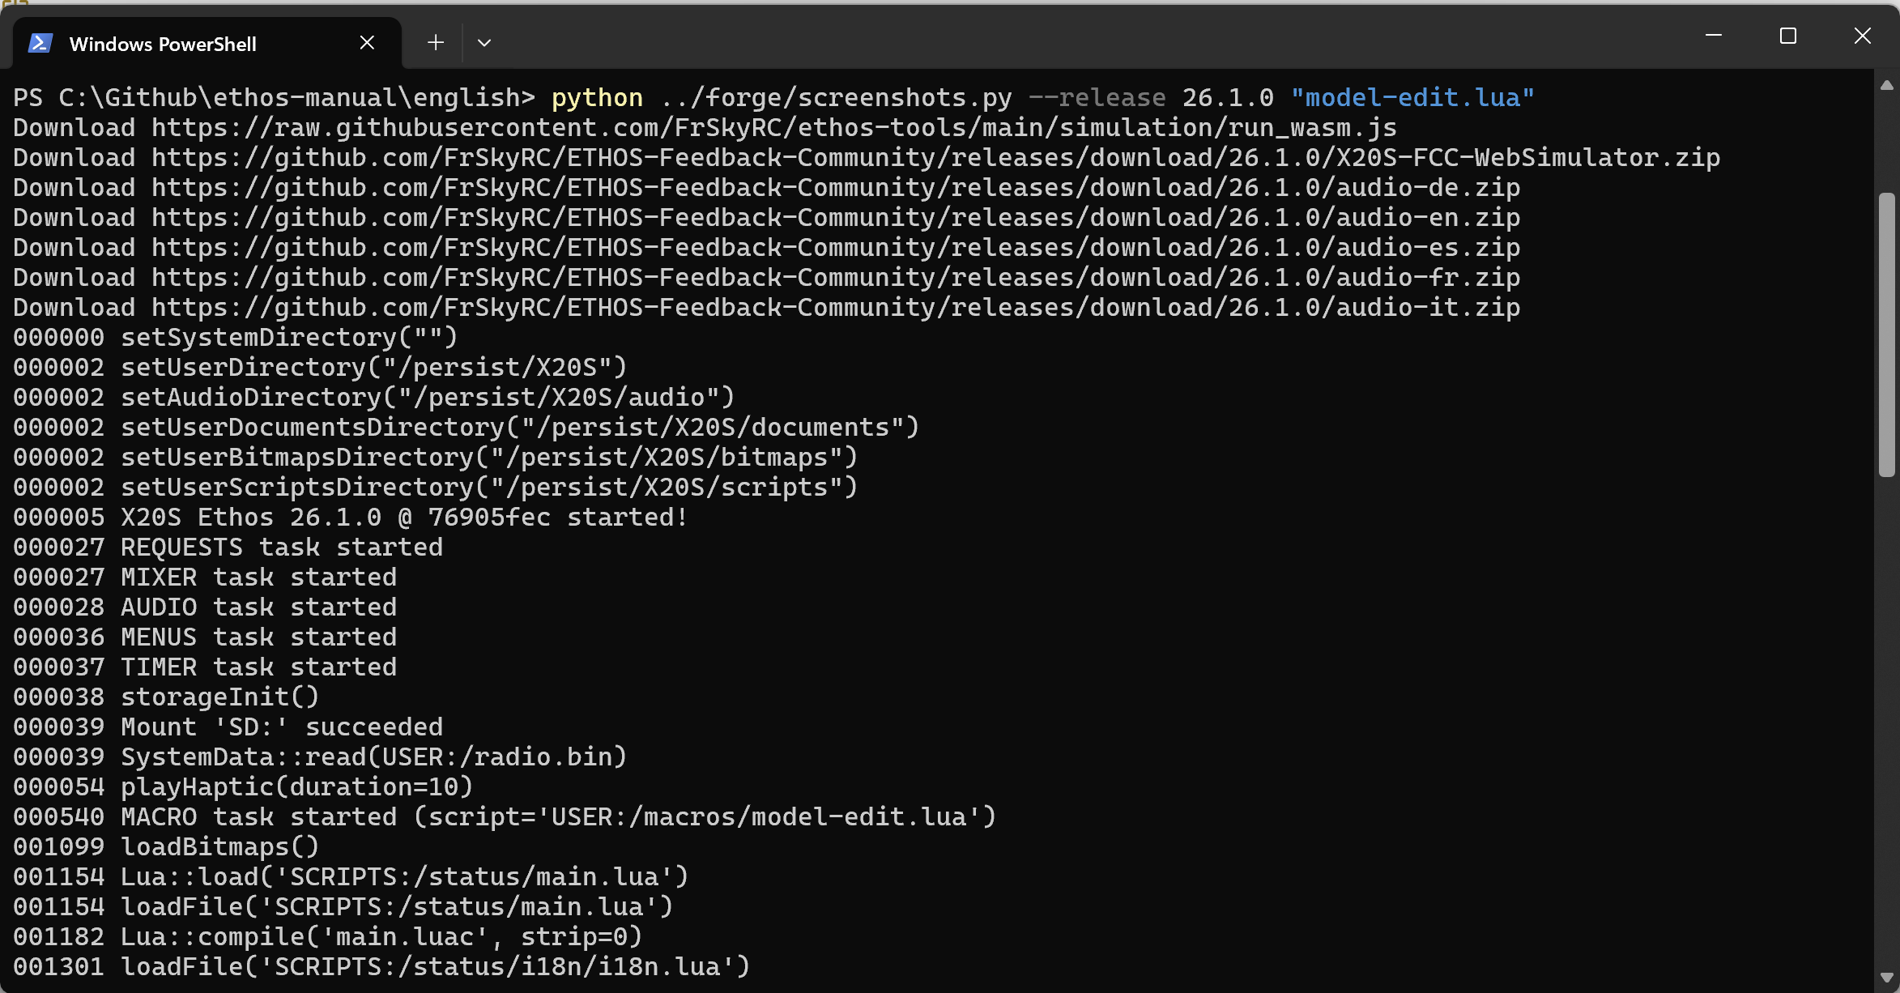

7. To test the process, run a short macro like ‘model-edit.lua’ by entering the command:
python ../forge/screenshots.py --release 26.1.1 “model-edit.lua”

This will run the ‘model-edit.lua’ macro.

Other options are:
To run all screenshots:
python ../forge/screenshots.py --release 26.1.1

To run all X20S screenshots:
python ../forge/screenshots.py --release 26.1.1 --radio X20S_FCC

At this stage there is no facility to run the ‘EU’ version, because we are only simulating. Often during early testing only the X20S_FCC is updated.

Note that sometimes you may have to add ‘--force’ to get it to download everything needed, e.g.

python ../forge/screenshots.py --force --release 26.1.1

Options for other radios:
--radio X18S_FCC
--radio X20PRO_FCC
--radio X20PROAW_FCC
--radio XERS_FCC

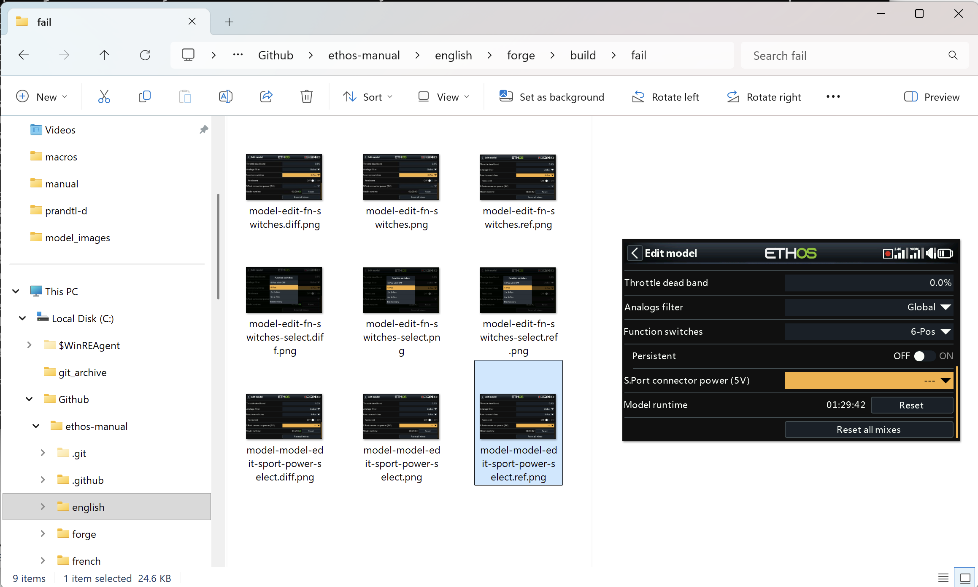

8. The `screenshots.py` script generates a `build` folder in your local ‘forge’ folder, with a subfolder called `screenshots`, which contains all the screenshots created by the macro(s).

In addition you will find a subfolder named `fail’:
C:\Github\ethos-manual\english\forge\build\fail

The ‘fail’ folder contains those screenshots which are either new or different to the ones currently in the ‘assets’ folder.

9. Once the script has completed, switch to Windows Explorer and navigate to the ‘fail’ folder.

For each screenshot which is different from the reference, you will have (for example):

model-edit-fn-switches.diff.png (this is a diff image showing differences in green)
model-edit-fn-switches.png (this is the new image)
model-edit-fn-switches.ref.png (this is the current reference image in the repo assets)

10. If there are errors or significant differences, let me know so that we can discuss them.

Up until this point, everything has been done in the ‘forge’ folders which are ignored by GitHub.

11. Once you are happy with the new screenshots, switch back to the Terminal window.

12. Ensure that you are in your <language> folder.

13. Type the command

python ../forge/accept.py

14. This this will copy the new screenshots to your assets folder.

15. Now load GitHub Desktop, it should show the new screenshots under the 'Changes' tab.

16. First do a Repository Pull.

17. Then enter a suitable Commit message, followed by a Push. Use the prefix [screenshots] to categorise the commit, for example:

[screenshots] Update EN system-menu

18. Once you are happy with the test run, you can run the full set as detailed in step 7.

19. Notes
In the Terminal log you will get these errors:
001259 Lua widget key '' not found
001260 Lua widget key '' not found
They occur because we force an error to get the red triangle in the radio topbar.

Note that GitHub ignores everything that happens in the ethos-manual/forge and the <language>/forge folders. So you can run the screenshots.py script as often as you wish. It is only when you execute the ‘accept.py’ step that the new screenshots in the ‘fail’ folder will be copied into your assets folder. At this point the new screenshots will appear in the Changes tab. You then need to do the Pull, Commit and Push steps to post them into the main GitHub repository from your local repo.

Background
The screenshots.py script will:
1) create a build directory and populate it with:
the localized radio.bin (from for example x20s-fr.bin)
the localized models directory (because for FR models have a french names and directories, like "Avions", "Planeurs"). It is important to note that if you modify any models you will need to maintain them yourself if any changes are made to the EN models.
2) download the audio from FEEDBACK repository (no need to store them in ethos-manual!)
3) copy the model / bitmaps (common to all languages)
4) copy documents/user (localized)
5) copy scripts (not localized)
6) copy macros (not localized)

